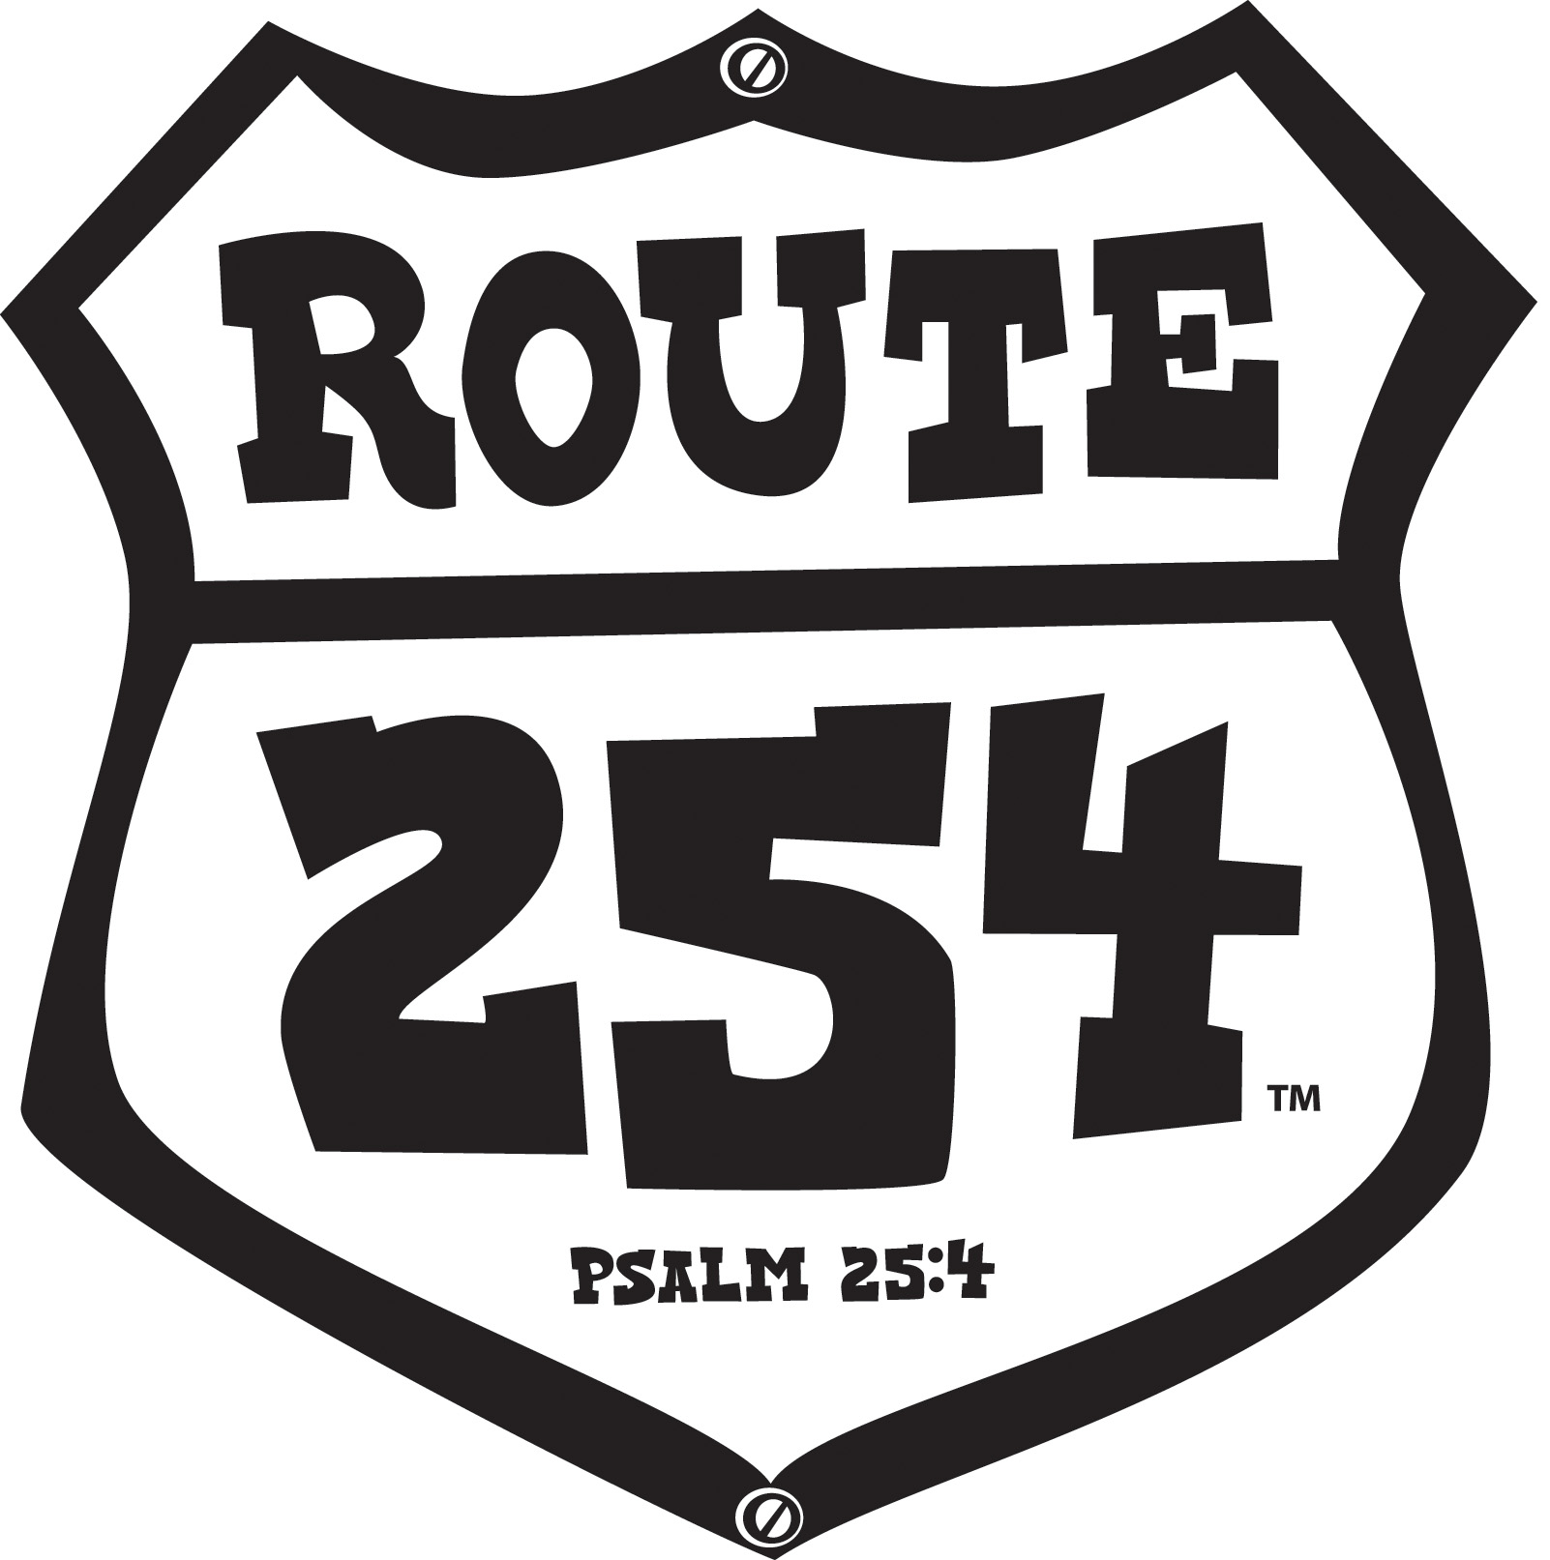

VBS 2010 Route 254 Children’s Base Conference Plan

Purpose Statement
This one hour plan is designed to prepare leaders who will be teaching LifeWay’s Club VBS: Route 254 Children’s Bible Study.

Resources to Collect
- LifeWay’s Club VBS: Route 254 materials for Children in 1st – 6th grade
- Pens or pencils
- Markers
- 5 brown bags
- 5 colors of extra small adhesive dots
- Snacks to place in conferee chair (Ex. Popcorn, Cracker Jacks, Smores cookie)
- Materials you choose for each rotation site

Resources to Prepare
- Focal wall Displays
- Make five travel bags using brown gift bags, cut off existing handle and attack a luggage handle using the letter “D”. Use markers to create the look of luggage around the edges of bag. Place travel Route 1 – 5 clipart sign on each bag (found at www.lifeway.com/clubvbs).
- Place Route 1 – 5 assignments in travel bag. Pages 18 – 12.
- Make four travel brochures from 8 ½ x 11 card stock. Make a 1-½ inch fold upward along bottom (11” side) of card stock to create a pocket on the inside of brochure when card is folded. The pocket will hold the assignment. Fold card from left to right. Trim right side to allow 3 inch width on brochure. Write Travel Brochure on outside of card. Use travel stickers, clip art or decorate with markers.
- Cut assignment content for four travel brochures. Page 13.
- Laminate motto: KNOW! FOLLOW! CHOOSE GOD’S WAY! from Route 254 punch out set.

Resources to Copy
- Page 6 (one copy per conferee)
- Pages 7 - 11 (one copy per group or if group is small one per person) Teaching Step 2
- Page 12 (one copy to prepare activity) Teaching Step 3
- Page 13 (one copy per person) Teaching Step 4

Focal Wall Description
Create a campsite atmosphere by hanging a painted canvas backdrop of an RV and trees. For depth, paint additional trees on foam board, cut out and prop in campsite. Extend a canopy over the door of RV. Crumble, tightly, brown paper bags to resemble rocks in order to create a campfire, place “rocks” in a small circle and add small pieces of wood to the center. (A pop –up tent is another option for the campsite.) Add a campstool, lantern, and other camping items to complete the campsite. Add props that are specific to the daily Bible Study. (Ex. Washington D.C., American Flag; Chicago, Bears or Cubs pennant; Lebanon, Sunflower; Yellowstone, stuffed wildlife animal; Knott’s Berry Farm, jar of jelly.) Make a sign, from cardboard or foam board, indicating BIBLE STUDY CAMPSITE. Other suggestions can be found in the Club VBS: Route 254 Administrative Guide on page 54. Clip art is available on the Administrative Guide CD-ROM or by visiting the LifeWay website: www.lifeway.com/clubvbs.

Room Setup Description
Place chairs in a semi-circle around the campsite. Create rotation sites around the room. Place a nametag, handout (Page 7) pen or pencil and snack in each chair.

Decoration Suggestions
Decoration ideas for rotation sites and the Bible Study Campsite can be found in the Club VBS Administration Guide. However, you might choose some of the following travel friendly and budget friendly ideas as you prepare your conference.

REC PARK (Recreation)
- Using a piece of cardboard cut a jagged sign and print “REC PARK” use markers to create the look of a weathered board.
- A large refrigerator box with a window cut in the box can be used as a “Rec Shack”. Cover with wood grained contact paper or use paint or markers to resemble wood. Hang or paint a “RENTALS’ sign over the window.
- Outdoor carpeting, cut from a roll, can be purchased very inexpensively for an outdoor effect.
- Use inflatable swim rings, rafts, and beach balls for additional props.
- Use a directional sign to point the way to recreational activities. (Ex: pool, hiking trail, canoeing, fishing, etc.)

CRAFTS SOUVENIR SHOP
- Using a piece of cardboard cut a rectangle sign and print “CRAFTS SOUVENIR SHOP” use markers to create the look of a framed sign. Place sign on a small easel and set among souvenirs.
- Use a floor easel and display a “SALE TODAY” sign in front of shop.
- On a wall display state pennants made from colored poster board or felt.
- Oversized price tags create a fun visual.

Check with members of your church for travel souvenirs to display in shop. (Ex: pennants, postcards, ball caps, travel cup, etc.)

SNACKS DINER
- Using a piece of white poster board or foam board, cut a square and print “SNACKS DINER” attach a string to each end of the top of the sign in order to hang. Using markers put a checkerboard pattern around edge of the sign.
- A “sandwich board” made from two pieces of foam board and attached at the top with packing tape can be displayed in front of diner. Write “DAILY SPECIALS” or menu items on board.
- For a retro floor or walls alternate 12 inch by 12 inch black and white squares cut from poster board.
- Hang old 45 records for a nostalgic look.

ROUTE 254 WORSHIP RALLY
- Roofing felt, on a roll, can be purchased to create a Route 254 road. Yellow duct tape can be used for centerline and white masking tape can be used for outer lines.
- Ask a local travel agency for discontinued travel posters.
- Travel maps with Route 254 destinations highlighted can be hung around room.

Audio Visual Needs
- TV/DVD to show Worship Rally DVD
- CD player

Teaching Procedures

Step 1 (5 minutes)
- Play “Route 254” (Instrumental, Track 1) from Grades 1 – 3 Leader Pack CD as conferees enter the room.
- Greet and welcome the conferees at the door. Give each conferee a small dot to place in the corner of nametag. Ask them to look around Route 254 and introduce themselves to one another. Have conferees tell the most interesting state they have visited and why they found it interesting.
- Gather the conferees together and play “Map Mania” found on page 79 of the Administrative Guide. (Materials for this game can be found in the Administrative Guide CD-ROM.)

Step 2 (20 minutes)
Say: “Tour guides, it is time to hit the road! The RV is packed and we are ready for some serious fun as we go cruisin’ coast to coast on Route 254. We will enjoy the sites of big cities, small towns, national parks and theme parks. But, most importantly, the Ramblers (children) will discover their true destinations are Worship, Thankfulness, Salvation, Belief, and Obedience. We have an opportunity to reach children, their families and our communities with the gospel through VBS. In 2008 over 86,000 decisions to accept Christ as Savior were reported as a result of VBS. More than 3200 people committed their lives to church related vocations during VBS and over 37,000 people enrolled in Sunday School as a result of VBS. What is your destination?”

Read Psalm 25:4.

Pray for the conference time and conferees.

Say: “Look around the room and someone tell me Club VBS: Route 254 motto? (Wait for response) Know! Follow! Choose God’s Way! At any point during our time together you hear me say: ‘What is your destination?’ You will respond with the motto, Know! Follow! Choose God’s Way! Point to your head when you say Know! Point straight ahead when you say Follow! Point upward when you say Choose God’s Way!” Use the “What is your destination?” phrase throughout the conference at appropriate times.

Say: “You will need to form five groups. Group yourselves based on the color dot you were given on arrival. One person from each group will select a Route 1, 2, 3, 4 or 5 travel bag (Prepare Step 2). In each travel bag you will find information pertaining to the five days of Bible Study. (Pages 8 - 12) Your assignment is to review with your group the route assigned. When called upon share your travel information with the rest of the tour guides. The travel information you find will help us discover our destination for traveling Route 254.”

Remind the conferees they will need to work together and may have to share resources as they complete their assignments.

Say: “When you hear the “nature sounds” you will have two minutes to complete your assignments and get ready to share your travel information.” Softly in play “How I Love You” found on Track 2 from the Bible Study CD Route 254 Grades 1 – 3 Leader Pack. After approximately 6 minutes, play Track 8 “Nature Sounds” found on the Bible Study CD Route 254 Grades 1 – 3 Leader Pack.

Allow each group two minutes to present their assignments. Make necessary and helpful comments about each day Bible Study as needed.

Step 3 (20 minutes) Cruisin’ Rotation Sites
Say: “It is time to jump back into our RV’s and cruise to our rotation sites. You will need to form four groups and appoint one lead tour guide to select your next assignment.”

Place travel brochure assignments (Prepare Step 4 & 5) throughout the room. Have the appointed lead tour guide from each group select a travel brochure and take back to his group to begin working on their assignment. Allow about five minutes to prepare and two minutes for each group to present their assignment.

Be prepared to make helpful comments pertaining to each rotation.

STEP 4 (10 minutes) Tracking the Ramblers
Say: “We may have reached our final destination on Route 254. The RV is unpacked, cleaned up and ready to hit the road again. However, our trip is not over just yet. In our remaining moments together I would like for us to complete this sentence: Club VBS: Route 254 road trip in not over until……” Give each conferee an opportunity to complete the sentence. You may also reference page 25 of Club VBS: Route 254 Administrative Guide.

Pass out page 14 to the conferees.

Step 5 (5 minutes) Final Destination (closing)
Say: “What an amazing road trip we have had together… destinations of Worship, Thankfulness, Salvation, Belief and Obedience. And we have so much more to look forward to as we prepare for Club VBS: Route 254, 2010. What a privilege to be able to share Jesus with boys and girls, their families ……”

Pray a special blessing for the conferees as they prepare and for the lives that will be changed as a result of VBS.

As conferees leave stand at the door and thank each one for cruisin’ Route 254 with you.

Cruisin' Route 254
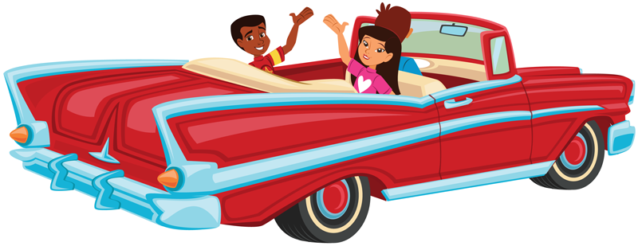

Club VBS: Route 254
What is your destination?
Ramblers in Grades 1 - 3

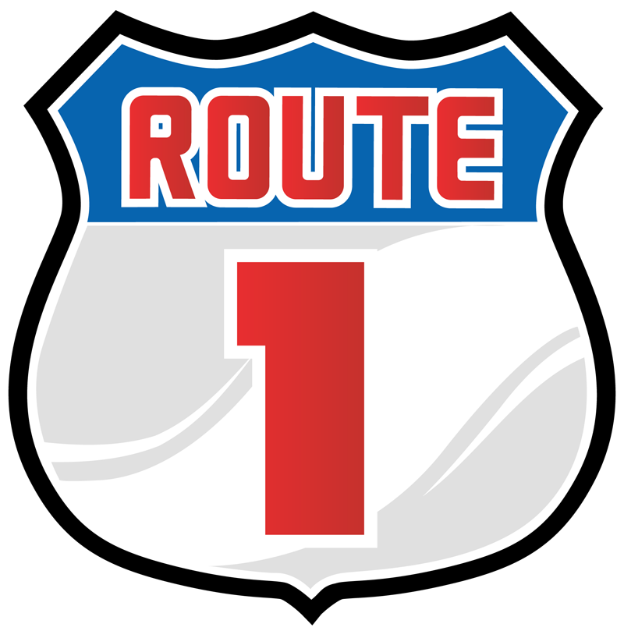

Bible Story:
1. Bible Story
2. Bible Verse
3. Life Application
4. Levels of Biblical Learning
5. What is the destination for Route 1 and How is it explained to the Ramblers in Get Started?
6. How are foil stars and a flashlight used in Learn It?
7. How will the Ramblers remember the daily Bible Verse reference in Remember It / Use It?
8. Who will the Ramblers be asked to pray for in Pray It?
9. How will the Leader Pack items be used in Review It?
10. How will the Learner Card 1 be used in Live It?
11. What song will be played as the Ramblers are Cruisin’ Out?

Club VBS: Route 254
What is your destination?
Ramblers in Grades 1 - 3

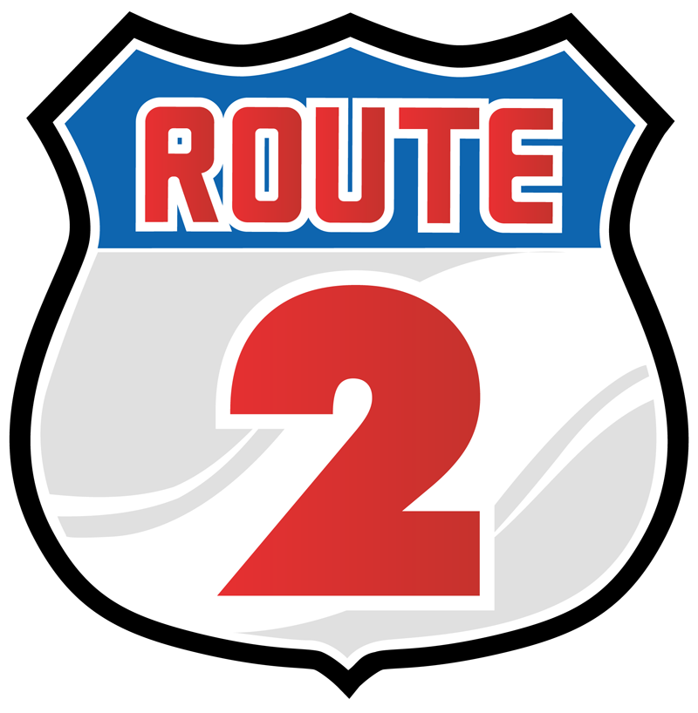

Bible Story:
1. Bible Story
2. Bible Verse
3. Life Application
4. Levels of Biblical Learning
5. How do you begin and end Get Started in Route 1?
6. What Leader Pack items and props will be used in Remember It / Use It?
7. What Bible story will the Ramblers hear in Learn It?
8. How will the Ramblers express thankfulness in Live It?
9. How will the song “How I Love You” be used in Pray It?
10. How will the Bible Study Lesson be re-enforced in Review It?
11. How is the daily Bible Verse used in Cruisin’ Out?

Club VBS: Route 254
What is your destination?
Ramblers in Grades 4 - 6

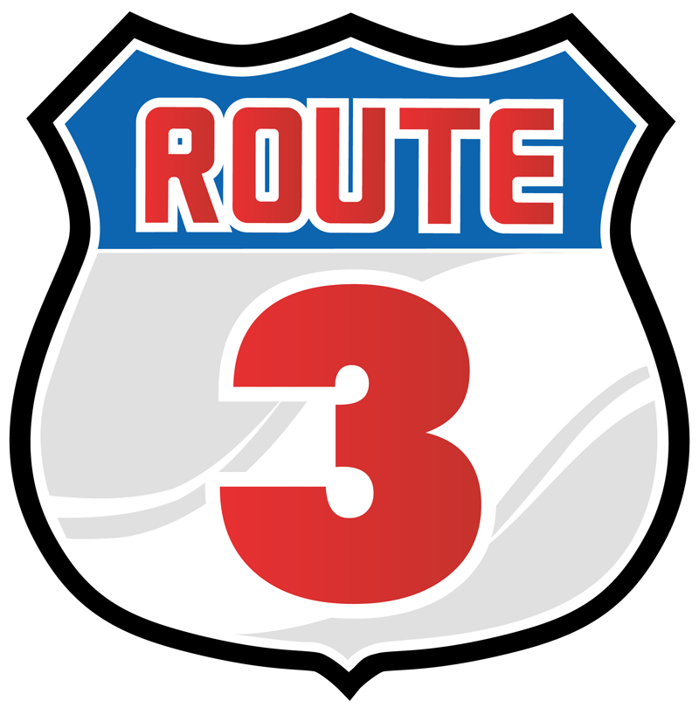

Bible Story:
1. Bible Story
2. Bible Verse
3. Life Application
4. Levels of Biblical Learning
5. What is Route 3 destination and why is it important as stated in Get Started?
6. How will “When? Where? Who? What?” questions be used in Learn It?
7. How will the “Why?” question be used in Live It?
8. How is the daily Bible Verse taught in Remember It?
9. How will Leader Pack items be used in Pray It?
10. What Leader Pack item will be used in Review It?
11. How is the Daily Challenge Card 3 used in Cruisin’ Out?

Club VBS: Route 254
What is your destination?
Ramblers in Grades 4 - 6

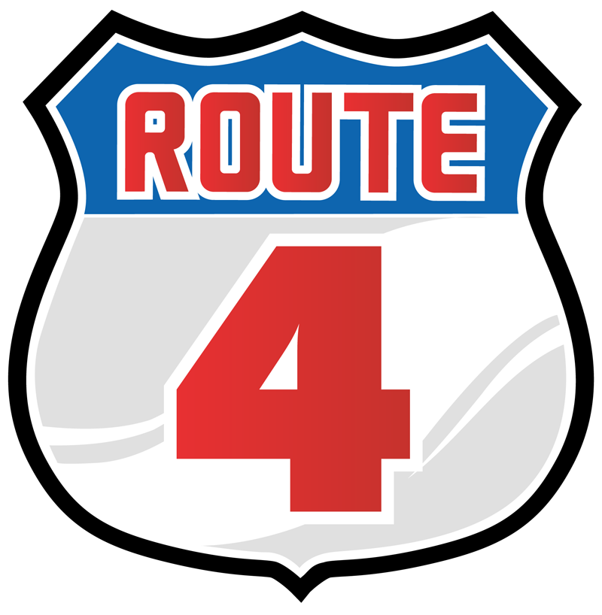

Bible Story:
1. Bible Story
2. Bible Verse
3. Life Application
4. Levels of Biblical Learning
5. What sites and sounds will be discovered in Get Started?
6. How is the question “Do you believe?” used in Learn It?
7. How is the daily Bible verse taught in Remember It?
8. Where do you find the “Wildlife Watch” activity answers in Live It?
9. What is the significance of a “log” in Review It?
10. How do we handle “doubt” with Ramblers as stated in Pray It?
11. How is the Daily Challenge Card 4 used in Cruisin’ Out?

Club VBS: Route 254
What is your destination?
Ramblers in Grades 4 - 6

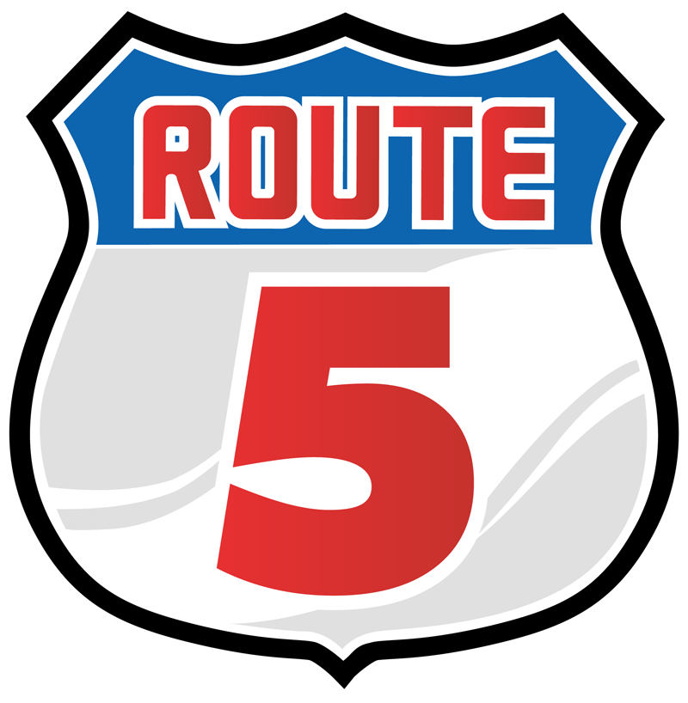

Bible Story:
1. Bible Story
2. Bible Verse
3. Life Application
4. Levels of Biblical Learning
5. How are the Ramblers welcomed into the campsite in Get Started?
6. How is the “Rules Cube” used in Learn It?
7. What will the Ramblers be asked to do to remember their daily Bible verse in Remember It?
8. What is Jesus’ command in the “Ways to Obey” activity in Live It?
9. What is the ultimate destination for all of us found in Pray It?
10. What leader Pack items are used in Review It?
11. What parting words are given to Ramblers in Cruisin’ Out?

Rec Park
As a group cruise over to the Rec Park. Review the daily game options and, using the supplies found in the Rec Park, be prepared to demonstrate a game to the group. Share with the group where you find game suggestions and supply lists

When you hear the music, remain at your work station.
Crafts Souvenir Shop
As a group cruise over to the Souvenir Shop.
Work together to make one of the daily crafts. Be prepared to share with the group where to find Route 254 craft suggestions and supply lists.

When you hear the music, remain at your work station.
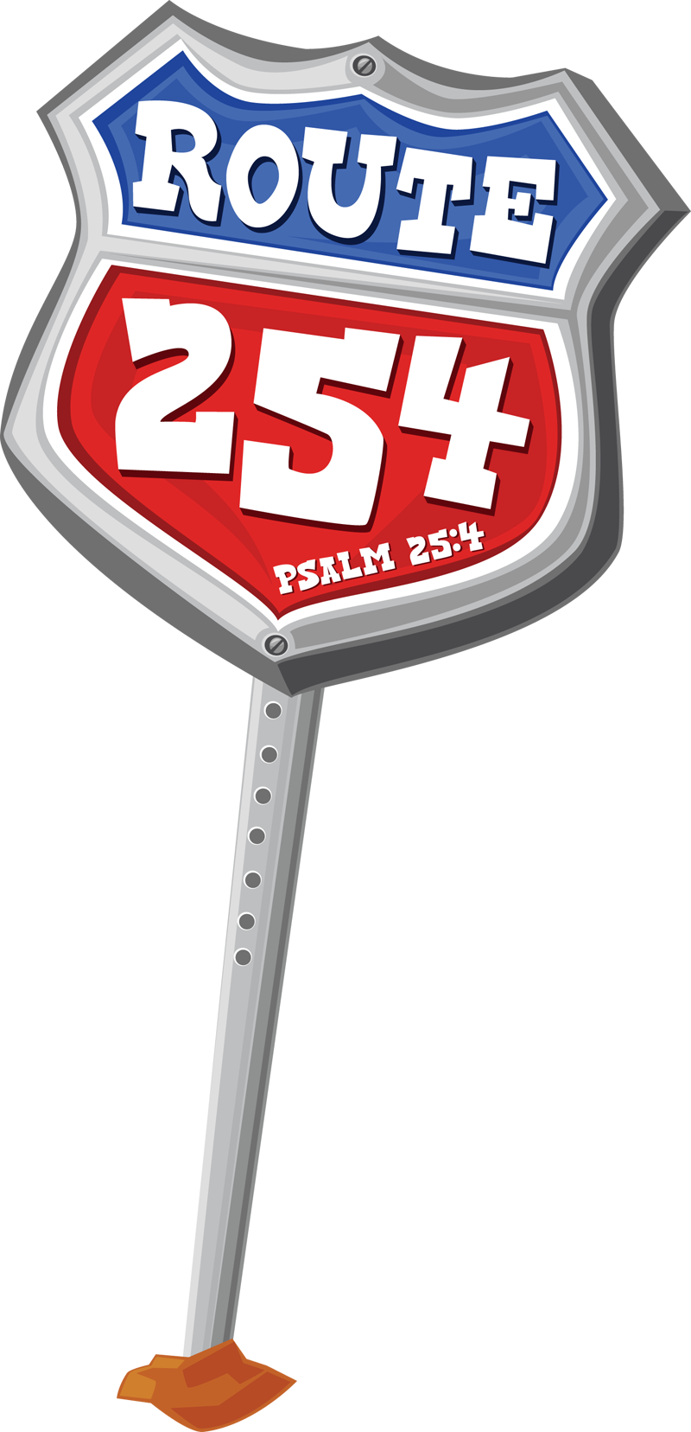
Snack Diner
As a group cruise over to the Rec Park. Using the supplies found in the diner, prepare one of the daily snacks. Share with the group other snack options and where you can find supply lists for snacks.

When you hear the music, remain at your work station.
Worship Rally
As a group cruise over to the Route 254 Worship Rally. Review the Worship Rally materials and DVD. Choose one of the songs to sing with the conferees.

When you hear the music, remain at your work station.
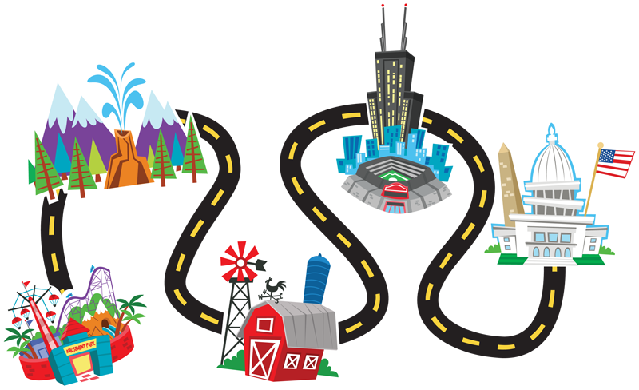

“The Route 254 road trip is not over until . . . “

.

.

.

.

.

.

